Total Marks: 35

Duration 90 Minutes

1. The database language that allows us to access data in a database is called : 2 MARKS

[A.](javascript:%20void%200;)DCL

[B.](javascript:%20void%200;)DML

[C.](javascript:%20void%200;)DDL

[D.](javascript:%20void%200;)None Of Above

ANSWER: DML

1. Which of the following is a legal expression in SQL? 2 MARKS

[A.](javascript:%20void%200;)SELECT NULL FROM SALES;

[B.](javascript:%20void%200;)SELECT NAME FROM SALES;

[C.](javascript:%20void%200;)SELECT * FROM SALES WHEN PRICE = NULL;

[D.](javascript:%20void%200;)SELECT # FROM SALES;

ANSWER: B

|  |
| --- |
|  |
|  |
| 3. BLOB data type can have default column value. 2 MARKS  A. True  B. False  ANSWER: B  4. How much storage space does DATETIME require? 2 Marks  A. 4 bytes  B. 2 bytes  C. 8 bytes  D. 1 bytes  ANSWER: C  5. Write a query to get the attendance count: 3 Marks    Tbl  SELECT emp,(length(datepresent) - length(replace(datepresent, ',', '')) +1) as TotalCount  FROM tbl; |

6. How to write a update query to swap the columns: 3MARKS

Tbl_2

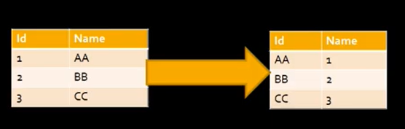

UPDATE student

SET id = (@temp:=id), id = name, name = @temp;

7. Can DISTINCT command be used for more than one column? 2 MRAKS

ANo

Byes

ANSWER: yes

8. On executing DELETE command, if you get an error "foreign key constraint"- what does it imply? 3MARKS

A Foreign key not defined

B Table is empty

C Connectivity issue

D Data is present in the other table

ANSWER: D

Q9. How can you improve the perfprmance of the query: 4 MARKS

1. Use indexes
2. Don’t use *
3. Use distinct and union only if necessary
4. Avoid wildcards
5. Use short alias table name

ANSWER: 1, 2, 3, 4

Understand the schema below and write the following queries:

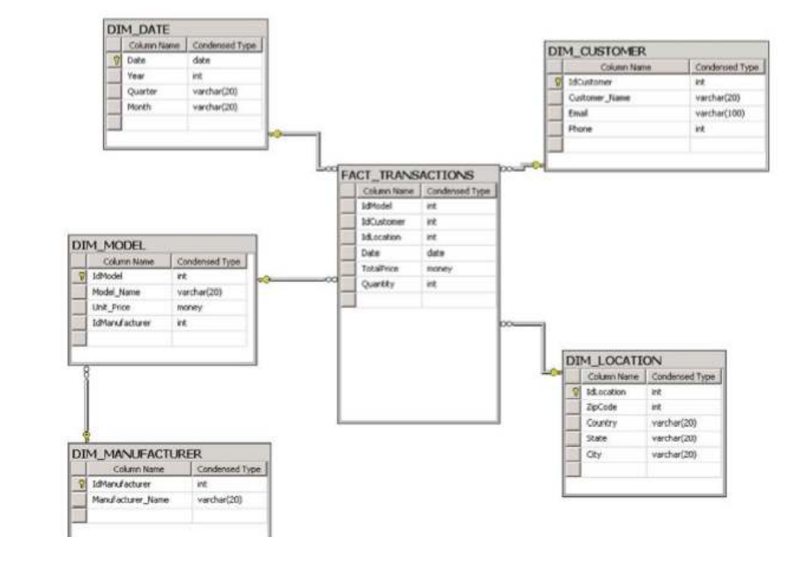

Q10. Show the manufacturers that sold cellphones in 2010 and not in 2009 5 MARKS

Select t1.Manufacturer_name from DIM_MANUFACTURER t1

Inner join DIM_MODEL t2

On t1.IdManufacturer = t2. IdManufacturer

Inner join fact_transactions t3

On t2.idmodel = t3.idmodel

Where t3.idmodel not in ( select idmodel from fact_transaction where year(date)=’2009’)

And t3.idmodel in ( select idmodel from fact_transaction where year(date)=’2010’);

Q11. Find top 100 customers and their average spend, average quantity by each year. Also find the percentage of change in their spend 7MARKS

SELECT t1.idcustomer, t1.customer_name, avg(t2.totalprice), avg(t2.quantity) FROM

Dim_customer t1 INNER JOIN fact_transactions t2

ON t1.idcustomer = t2.idcustomer

INNER JOIN dim_date t3

ON t3.date = t2.date

GROUP BY t3.year

ORDER BY DESC

LIMIT 100;